

Lab No:02 Date:2082/09/13
Title: Explain the cost based query planning using explain and analyze in Oracle Query Cost and Plan in oracle.
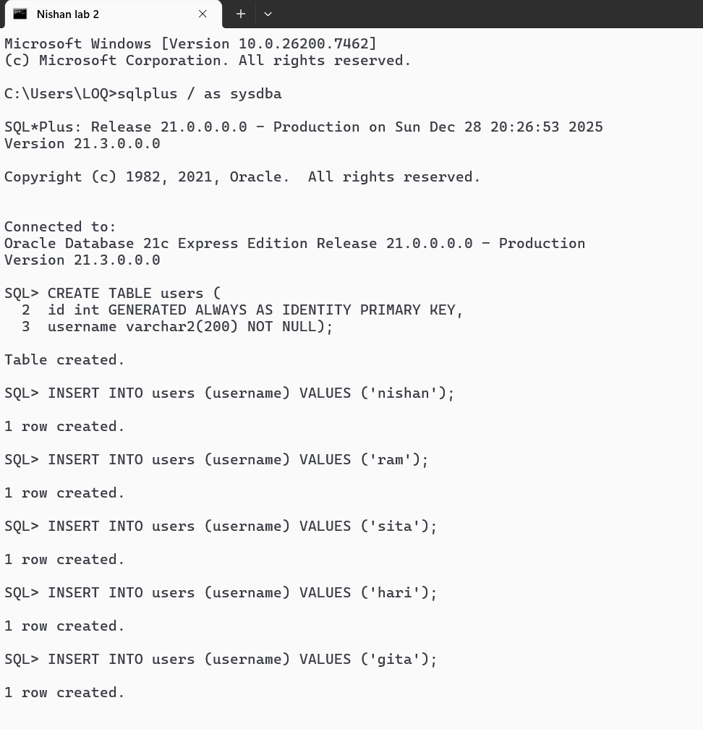
Cost-based query planning in Oracle is performed by the Cost-Based Optimizer (CBO), which selects the most efficient execution plan for a SQL query based on statistics such as table size, indexes, and data distribution. The EXPLAIN PLAN statement shows the estimated execution plan and cost, while ANALYZE (or execution statistics) provides actual runtime performance details, helping compare estimated versus real query behavior.
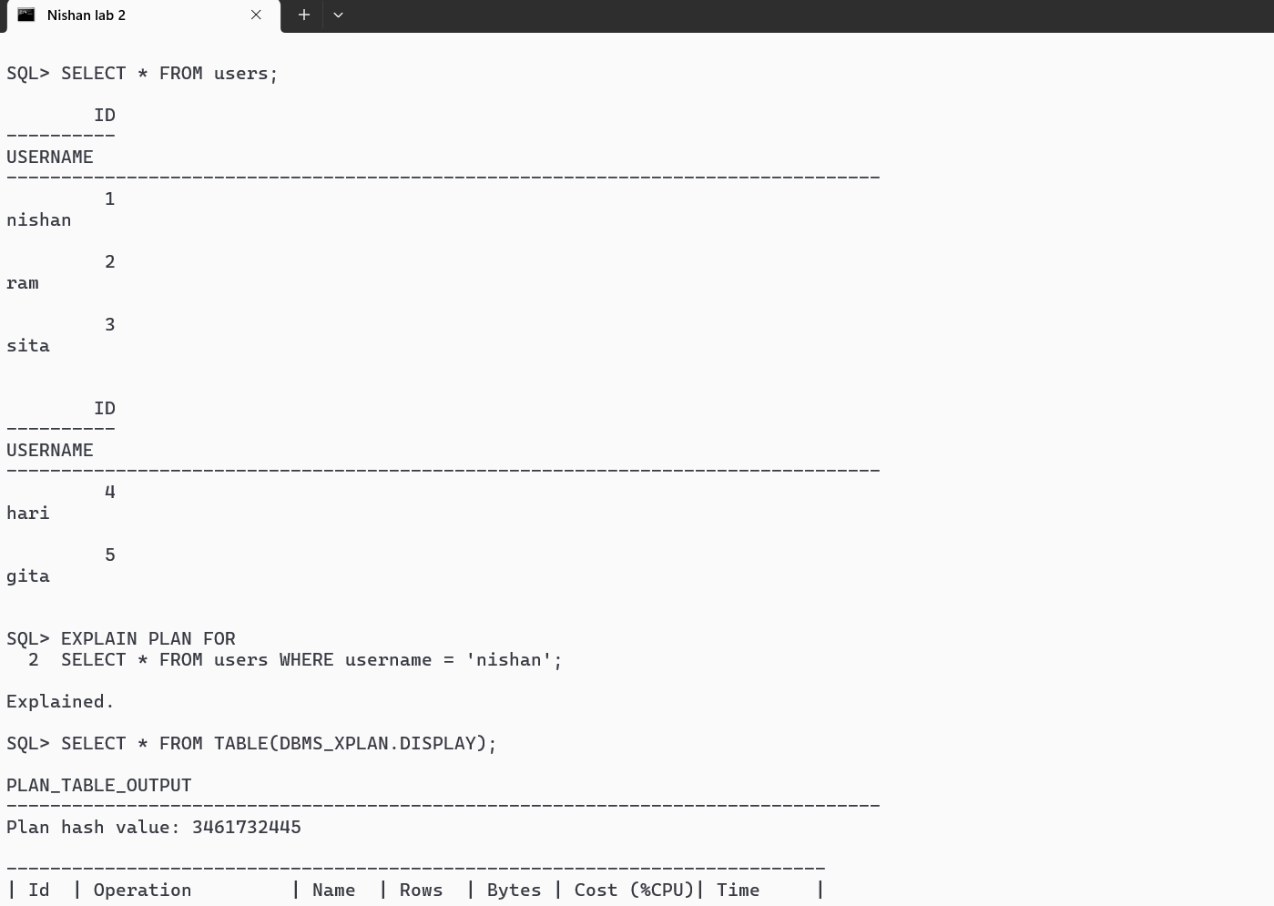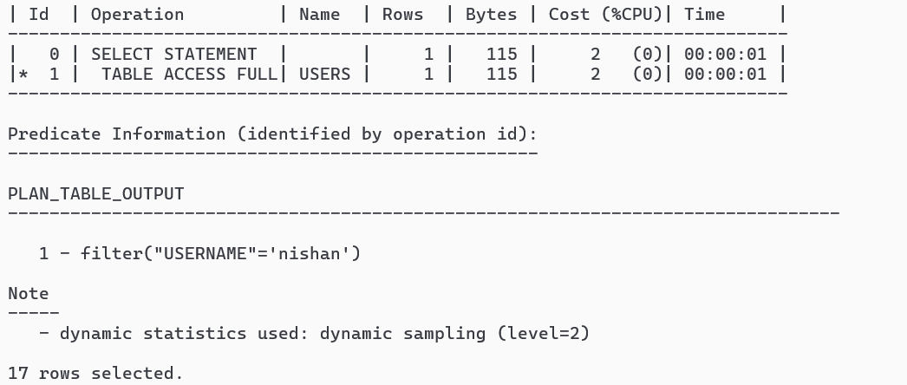
The EXPLAIN PLAN statement displays the execution plan chosen by Oracle’s Cost-Based Optimizer before the query is executed. It shows the sequence of operations, access paths (such as table scan or index scan), and the estimated cost of executing the query. This helps in understanding and optimizing query performance.

